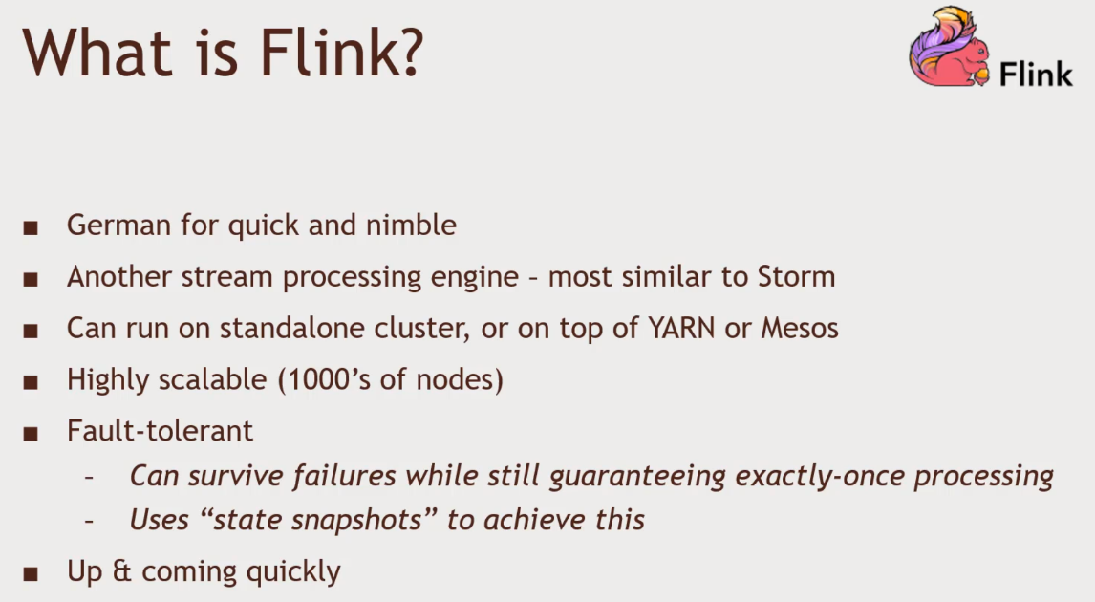Flink

Similar to Storm. Doing streaming by event and event basis.

Spark streaming’s ‘Structured Streaming’ paves the way for real event-based streaming in Spark

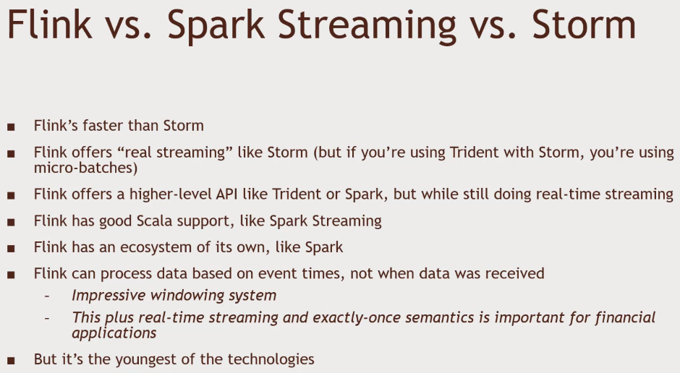Becomes more a question of what fits bets in you existing environment

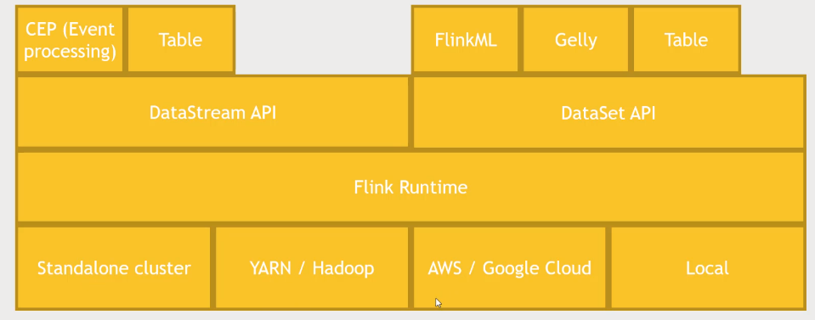Flink Architecture

Connectors

* HDFS
* Cassandra
* Kafka
* Others Elasticsearch, NiFi, Redis, RabbitMQ

Practice Flink

1. Hortonwork Sandbox VirtualBox And Login to Putty SSH Console
2. Need to Install Flink
   1. Download Flink from web browser
   2. Copy the link address of the link download address and wget + right mouse button to paste into putty
   3. Wait for it to download.
3. Going through one of the Example provided by the Library
   1. tar -xvf flink+tab
   2. cd flink-1.2.0
   3. Change the port of the web ui
      1. cd conf
      2. vi flink-conf.ymal
      3. jobmanager.web.port: 8082
   4. cd..
   5. ./bin/start-local.sh to kick off Flink
4. 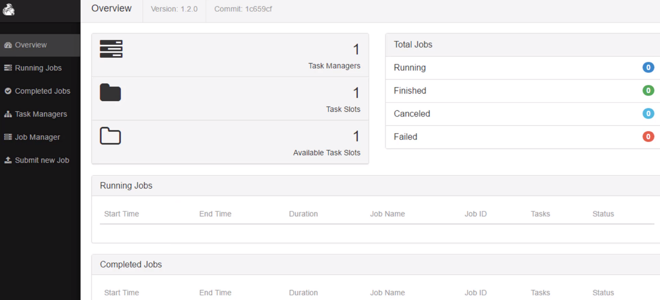You will get to the Flink UI
5. Flink is written in Scala. And you will see in Github.
6. Open up a port to Listen to
   1. NETCAT
   2. nc -l 9000
7. Open up another console and kick off Flink
   1. cd flink-1.2.0
   2. ./bin/flink run examples/streaming/SocketWindowWordCount.jar --port 9000
8. You open Up Flink UI and you will see the job.
9. Feed in some data and see the log file
   1. Open up another console
   2. cd flink-1.2.0
   3. cd log/
   4. ls
   5. cat flink-maria_dev-jobmanager-0-sandbox.hortonworks.com.out

Exit, Ctrl+C on netcat, and lose the streaming job, Shutdown flink service **./bin/stop-local.sh**